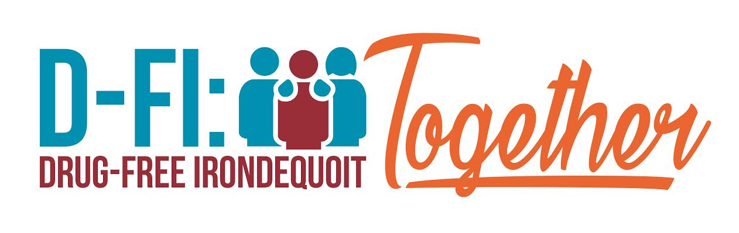
Champions for Drug-free Youth

Coalition Guiding Principles
January 2020 (rev.)

Section I: By-Laws

Drug-Free Irondequoit: Together (hereinafter referred to as DFI), is a community coalition focused on nurturing happy, healthy, drug-free youth in Irondequoit that was founded in September 2016 and incorporated in September 2017 as a 501c3 organization.

The by-laws adopted in September 2017 by the Executive Committee of the Board of Directors, are used to govern DFI as a not for profit corporation. The Guiding Principles shall be used to govern the Coalition.

DFI will operate according to its by-laws, governed by the Board of Directors.

Section II: Who We Are

Drug-Free Irondequoit: Together has adopted the following vision and mission.

Vision: To create systemic change of beliefs, attitudes, perceptions and practices associated with the use of alcohol, tobacco, and other drugs among youth, their families and the community at large, in order to build a safe, healthy and drug free community.
Mission: D-FI: Together will establish and strengthen collaboration among multiple community sectors to develop and support the implementation of programs and activities related to prevention, education and reduction of youth substance use.
Elevator Speech: We are the leading non-profit drug and alcohol prevention organization in Irondequoit and the surrounding communities. We are making our community a safer place by educating people while offering resources and activities to improve youth outcomes.

DFI serves the Town of Irondequoit and uses the Strategic Prevention Framework as our foundation with a focus on the Seven Strategies for Change in the Logic Model.

Section III: Membership

- Representation:
The membership of DFI is made up of representatives from a multitude of sectors including individuals as well as representatives from organizations. Sectors required, but not limited to are in the list that follows:

- Youth
- Education
- Parents
- Media
- Business
- Law Enforcement
- Local Government
- Religious and/or Fraternal
- Health Care
- Other agencies related to substance prevention, abuse and/or treatment
- Civic and volunteer groups
- Youth serving organizations
- Any other members as defined by the needs of the Logic Model and Action Plan

- Duties and responsibilities:

- Job descriptions are outlined for all of the Executive Committee positions. Currently the Project Coordinator Position is being filled on a voluntary basis by the Chair of the Board.

- Member positions are based on the Coalition Involvement Agreement which shall be signed at the Large Coalition Meeting every January.
Duties include and may be altered with the recommendation and decision by Executive Committee:
- Being a community leader amongst the represented sector.
- Ensuring clear communication between the sector represented and the coalition
- Acting as a positive role model for youth, families, and peers.
- Supporting the coalition’s mission.
- Attending Coalition at Large Meetings as is feasible and pertinent.
- Participating on at least one subcommittee as is appropriate.
- Attending coalition sponsored trainings, town hall meetings, and other community events as asked and needed.
- Contributing to the strategic action planning process.
- Volunteers will keep a running log as provided by the Board of Directors of hours for all activities and meetings which will be used as a grant funding match if applicable.
- Participating in sustaining the coalition’s capacity, involvement, and goals.
- Follows Drug-Free Irondequoit: Together Coalition Code of Conduct (note: This is a separate policy which is given to all members at the time of their initial meeting but shall be attached to these principles)

Section IV: Meetings
- Coalition Meetings: an annual meeting calendar shall be presented by the Executive Committee no later than the Large Coalition Meeting in May of each year. This calendar will be developed with Coalition at Large meetings as well as Executive Committee meetings for September to August of each year. Every effort will be made to adhere to the calendar with decisions to cancel or add meetings as needed and agreed upon by Executive Committee throughout the year typically via email notification.
- Sub-Committees shall typically meet monthly or bi-monthly as determined by its committee members in order to accomplish its work.
- An Annual Coalition at Large Meeting shall be held typically in June as an evening Community Meeting with the express purpose of sharing the work accomplished by the coalition over the past academic year.
- Special meetings may be called by the Executive Committee with at least 7 business days advance notice except in the case of an emergency
- No quorum is required to hold coalition meetings except in the case of Executive Committee.
- All meeting attendees are eligible to vote and decisions shall be made by simple majority of votes.
- Meeting minutes shall be take at all coalition meetings, and sub-committee meetings and shared through email to coalition at large members.
- All Coalition at Large meetings shall have an agenda and will not be bound to Robert’s Rules of Order but more of a congenial, respectful and casual style.
- Cancelation of Meetings: A notice of meeting cancelation can be provided I the same manner in which it was scheduled.

Section V: Sub-Committees
- The Executive Committee or designated facilitator shall make appointments to all sub-committees. The Executive Committee or designated facilitator shall be guided by Committee members’ stated preferences for sub-committee assignments.
- Each sub-committee shall identify its chairperson. The Chairperson’s responsibility is to facilitate meeting organization with reminder notices of meetings and appointing of someone to take minutes and send to the President/Chair of the Board of Directors.
C. A list of standing Committees will be kept up to date annually.

- Ad hoc committees can be formed by the coalition as needed.

Section VI: Amendments

- Proposed amendments to these Guiding Principles shall be brought forward to the Executive Committee prior to the regular coalition meeting for consideration.
- These Amendments will be presented in writing to the coalition members at the next regular coalition meetings to allow for discussion.
- A motion shall be made and voted on either at the meeting in which it is presented or may be tabled for a vote at the next regular coalition meeting.
- The Executive Committee is responsible for making changes as voted upon by the coalition.

Section VII: Dissolution of the Coalition

In the event of the dissolution of the coalition, its assets and liabilities shall be the responsibility of the Board of Directors, with input from the Coalition at large.

